# 一、创建一个可以远程访问MySQL的用户

## 1、用户名HealeJean 密码147094

#### GRANT ALL PRIVILEGES ON *.* TO 'HealerJean'@'%' IDENTIFIED BY '147094' WITH GRANT OPTION;

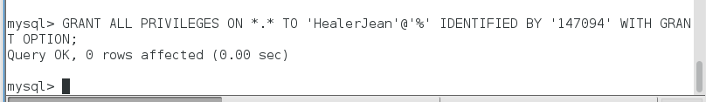

# 2、修改生效

#### FLUSH PRIVILEGES;

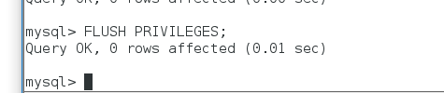

# 3、后续再接吧，朋友